Fountain-Fort Carson High School
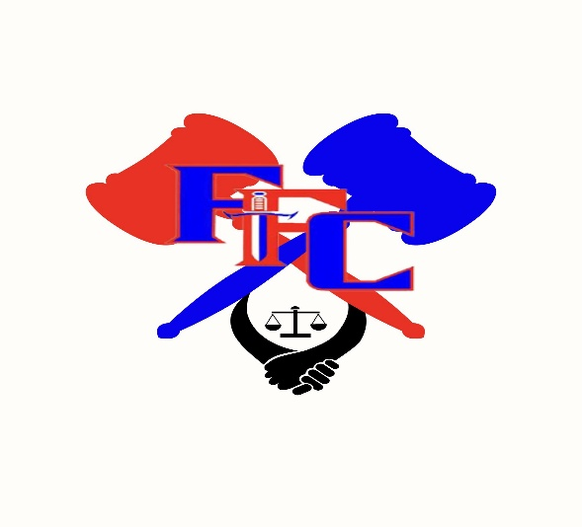
2025 Trojan Invitational
Speech and Debate

The Fountain-Fort Carson High School team would like to invite you and your team to the 2025 Trojan Invitational on Saturday, November 15, 2025. We will be running a wave-style tournament, including powered debates, doubling and finals in all events. This tournament will follow CHSAA rules for all events.

If you have any questions, please call or text Kenya Monger (720-726-0903) or email kmonger@ffc8.org.

Location and Payment Address:
Fountain-Fort Carson High School
900 Jimmy Camp Rd.
Fountain, CO 80817

Registration:
Please register your team at www.speechwire.com by Wednesday, November 12. Early registration is encouraged. We will charge $10.00 per single entry of Drama, Humor, Poetry, POI, Extemporaneous (NX and IX), Info, and Oratory and $20.00 for all Debate and Duo entered in the tournament and $7 per Congress entry.

You may have up to 4 entries per competition event except Congress which will be limited to 10 entries per school. Additional entries may be waitlisted. Tournament entry fees will be based on your pre-registration numbers; any drops made after November 12 will forfeit the entry fee.

Please make checks payable to Fountain-Fort Carson High School Speech and Debate, noting which school has made the payment. Please wait to pay until after the tournament when invoices have been adjusted to reflect any incurred judge fees.

Doubling:
Red Wave: NX, IX, OO, Drama, Humor, Varsity LD, Novice PF, Congress A
Blue Wave: Duo, POI, Poetry, INFO, Varsity PF, Novice LD, Congress B

Students may enter in one Red Wave and one Blue Wave event (But they cannot double in two debate events unless one–not both–of those events is Congress).

NOTE: Extempers who double are not guaranteed prep time.

Extemporaneous Draw:
Draw will take place 30 minutes prior to the scheduled start of the round.

Schedule:
Rounds will be run as soon as possible. Please watch the postings.
07:00 AM Registration Opens
07:20 AM Registration Closes
07:45 AM Judges Meeting
07:50 AM Extemporaneous Draw Begins
08:00 AM Red Wave Round 1 (Extemporaneous NX/IX round 1 will start at 8:20)
09:30 AM Blue Wave Round 1
11:00 AM Red Wave Round 2
12:30 PM Blue Wave Round 2
02:00 PM Red Wave Round 3
03:30 PM Blue Wave Round 3
04:30 PM Finals will begin (All Finals will start as soon as possible)
06:30 PM Awards
07:30 PM Head Home
Competitors more than 10 minutes late to a round forfeit that round. Competitors will speak in the order they were assigned. Please remind students not to enter a room until the judge is present.

If you are running late the morning of the tournament, please call or text Kenya Monger’s cell phone (720-726-0903) to notify when you will be arriving. Arrivals after 7:30 may be dropped from the first round.

Debate Topics:
LD (Nov/Dec topic): Resolved: The United States ought to rewild substantial tracts of land.

PF (Nov/Dec topic): Resolved: The United States federal government should require technology
companies to provide lawful access to encrypted communications.

Debate/Congress:
PF debaters will use the November-December NSDA Topic. LD debaters will use the November-December NSDA Topic. Debate rounds will be power matched after round 1. Cell phones may be used as timers, provided they are in airplane mode.

We will use CHSAA rules for internet usage. Students will have access to the internet. Warning: it is filtered.

BILLS AND RESOLUTIONS:
We must have any submissions by Friday, October 31, to Kenya Monger (kmonger@ffc8.org). Your legislation will only be considered if it has been thoroughly proofread and is in standard NSDA format; please submit legislation as Word documents. Bill packets will be sent out on Monday, November 3, by email to everyone who has pre-registered.

Judges:
Each school must provide judges based on competitors: 1-5 Speech/Interpretive entries will require one judge, 6-10 will require 2 judges, etc.; 1-2 Debate entries will require one judge, 3-4 will require 2 judges, etc. Congress judges will be categorized under the Speech requirement. Judges must be available for the three preliminary rounds and the final round–if you are dividing a judging requirement across multiple judges, please ensure there is judge coverage for the whole duration of the tournament. Judges should be entered by Wednesday, November 12.
An uncovered judge requirement on Saturday may incur a fee of $50.

We will be using eballots, so be sure that your judges have Speechwire accounts and that they bring their laptops. Here is a video to help judges understand eballots on Speechwire: Judging Speech and Debate on Speechwire (right click to open hyperlink)

Awards:
Awards will be presented to 1st -6th place winners as well as outstanding and superior speakers. Plaques will be awarded for Sweepstakes.

Food:
Breakfast, lunch and snacks will be provided for judges and coaches. Food Trucks will be available for lunch from 11:00AM to 2:00PM. Concessions will be available from 8:00AM to 5:00PM. Competitors will need to bring money for food trucks/concessions or their own food for the day.

School Rules:
- The tournament will be governed under the rules set forth by CHSAA and Fountain-Fort Carson District 8.
- The Fountain-Fort Carson District 8 schools are tobacco-free campuses.
- Please respect the teachers who allow us to use their rooms by leaving the room in the same condition in which you found it.
- A responsible coach must always be available ON SITE and via cell phone during the tournament.

Looking forward to seeing you soon!

Kenya Monger
FFCHS Speech and Debate Coach
kmonger@ffc8.org
720-726-0903

